**­­­**

Supporting Information: **Fluorescence lifetime imaging detects long-lifetime signal associated with reduced pyocyanin at the surface of *Pseudomonas aeruginosa* biofilms and in cross-feeding conditions**

Tara Gallagher*1, Simon William Leemans*2, Alexander Dvornikov2, Kumar Perinbam3, Joshua Fong1, Christina Kim1, Joseph Kapcia1, Miki Kagawa1, Adam Grosvirt-Dramen4, Allon Hochbaum4, Michelle Digman2, Enrico Gratton2, Albert Siryaporn3, Katrine Whiteson#1

* T.G. and S.W.L. contributed equally

# Corresponding author: Katrine Whiteson, katrine@uci.edu

1. University of California Irvine Department of Molecular Biology and Biochemistry

Irvine, CA, US 92697-2525

1. University of California Irvine Department of Biomedical Engineering

Irvine, CA, US 92697-2715

1. University of California Irvine Department of Physics and Astronomy

Irvine, CA, US 92697-4575

1. University of California Irvine, Chemical Engineering and Materials Science; Chemistry

916 Engineering Tower

Irvine, CA, US 92697-2575

**Figure S1**: Two-photon fluorescence emission spectra of *P. aeruginosa* fluorophores characterized with a hyperspectral imaging microscope (excitation = 740 nm, emission window = 400-690 nm). (**A**) The fluorescence emission spectra, normalized by max peak intensity of fluorophores. (**B**) The raw fluorescence is also depicted. Worth noting, different concentrations of fluorophores were used for spectral imaging (see Methods). The gray window (400-500 nm) represents the emission filter used for downstream image acquisition of bacterial samples with the DIVER FLIM microscope. CPX = coproporphyrin, FAD = flavin adenine dinucleotide, NADH = nicotinamide adenine dinucleotide hydrogen, OHPhz = 1-hydroxyphenazine, PCA = phenazine-1-carboxylic acid, PCN = phenazine-1-carboxamide, PVD = pyoverdine, PYO = pyocyanin.

**Figure S2:** (A) Two-photon fluorescence spectra (excitation of 740 nm) of 500 µM pyocyanin when reduced with a gradient of TCEP or of 821 µM pyocyanin electrochemically reduced (EC). The fluorescent emission spectra of electrochemically-reduced pyocyanin was shifted slightly to the left (shorter wavelength) of TCEP-reduced pyocyanin (1:1 pyocyanin:TCEP ratio). (**B**) Fluorescence lifetime phasor signal of 500 µM pyocyanin when treated with a gradient of TCEP. As the amount of TCEP increased, the phasor signal shifted further to the left. (**D**) 1:1 TCEP-treated pyocyanin had a FLIM phasor signal shifted further to the left than electrochemically reduced pyocyanin. PYO = Pyocyanin.

**Figure S3**: While imaging across *P. aeruginosa* biofilm depths, laser power was increased in a step-wise fashion to account for signal attenuation (20% to 59%). The fluorescent intensity across different biofilm depths was similar. (**A**) Example of fluorescent intensity from an image of the biofilm surface. (**B**) Example of fluorescent intensity histogram from an image 1 mm into the biofilm. The bars are colored by relative fluorescence signal, where red is indicative of higher RFU. (**C**) ­­Photobleaching does not impact the FLIM phasor signal. The mean G and S coordinates were determined for WT PA14 biofilm samples, where all frames were used in the calculation (“all”) and compared to the first frame only (“first”). (**D**) The FLIM phasor noise is higher when a median-filter is applied to one frame versus all the frames acquired for a given image.

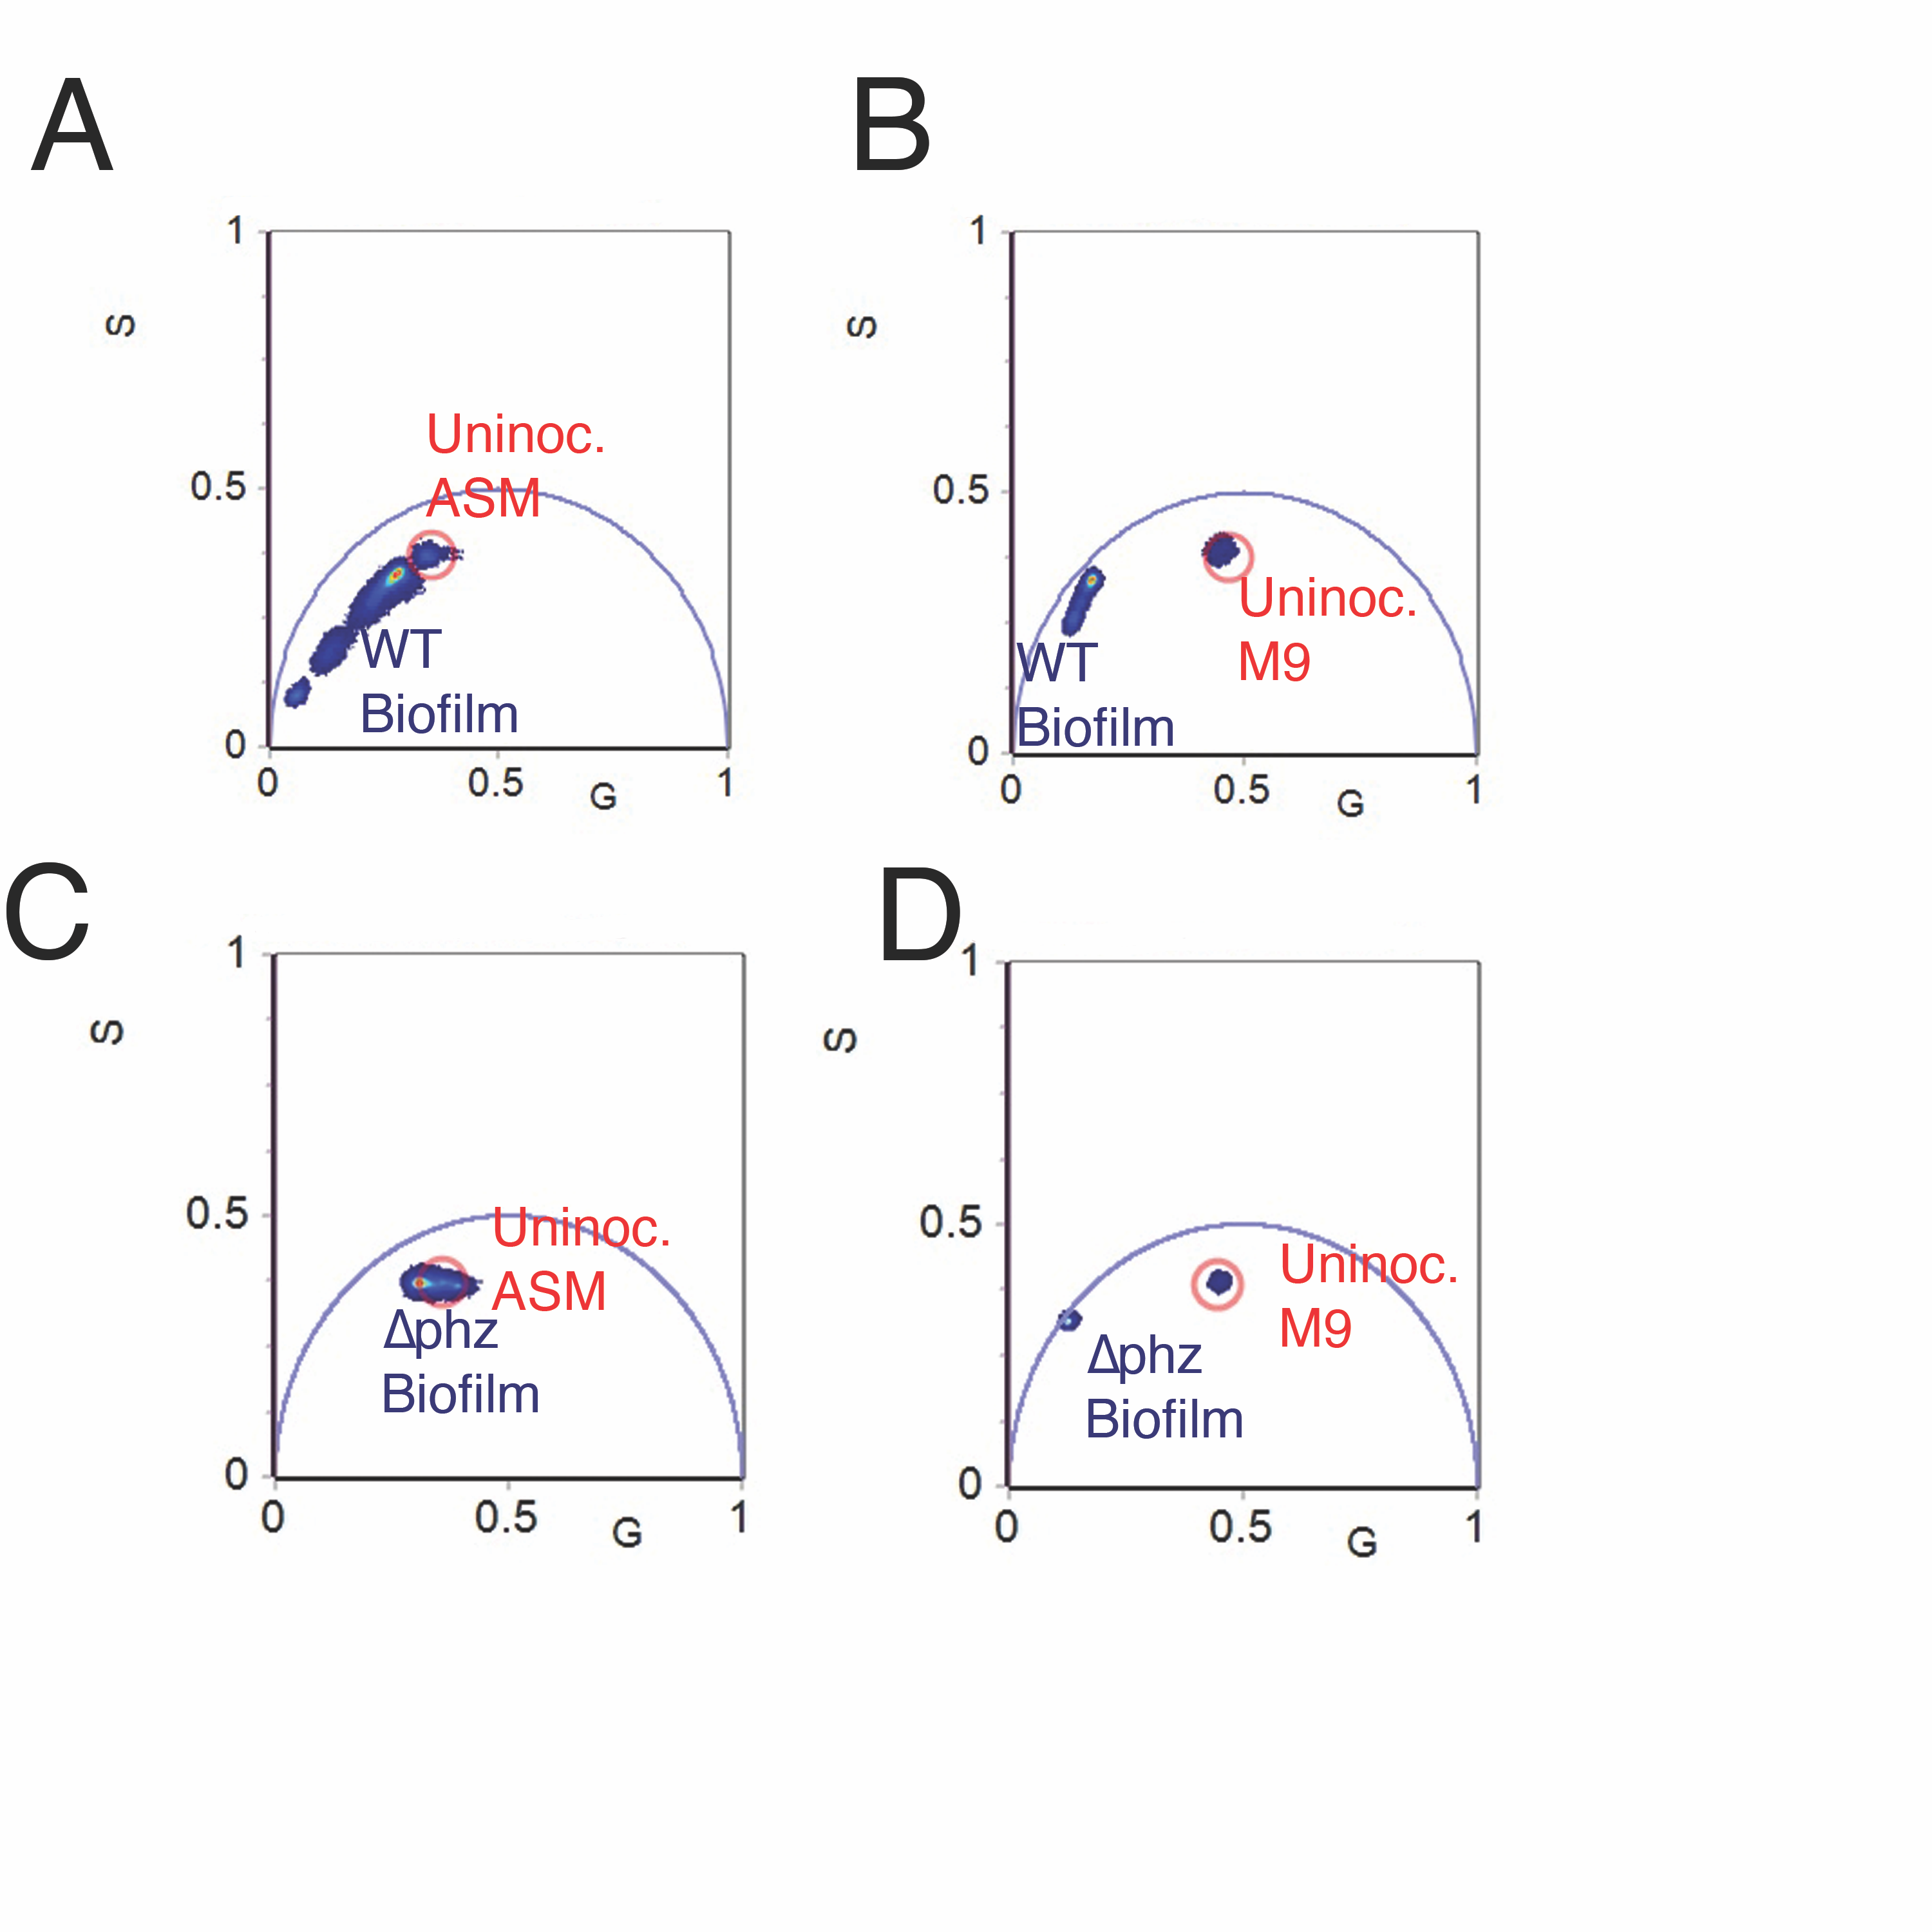

**Figure S4**: FLIM phasor signal of (**A**) un-inoculated artificial sputum medium (ASM) agar (pixels inside of the red circle) compared to WT *P. aeruginosa* PA14 biofilms in ASM agar; (**B**) un-inoculated M9 succinate agar compared to WT *P. aeruginosa* PA14 biofilms in M9 succinate agar; (**C**) un-inoculated ASM agar compared to ∆phz biofilms; (**D**) un-inoculated M9 succinate agar compared to ∆phz biofilms. The only biofilm condition with overlapping FLIM signal to uninoculated media was ∆phz grown in ASM.

**Figure S5**: The fluorescence lifetime (FLIM) signal of *Pseudomonas aeruginosa* can be longer than that of other microbes. FLIM phasor signal of (**A**) *P. aeruginosa* PaFLR01 grown in M9 succinate with *Rothia mucilaginosa* RmFLR01supernatant in hypoxic conditions (phasor data displayed from 7 images). (**B**) *P. aeruginosa* PaFLR01grown in artificial sputum medium (ASM) in hypoxic conditions (7 images). (**C**) *Stenotrophomonas maltophilia* FLR19 grown in Todd-Hewitt Broth (THB) in aerobic conditions (8 images). (**D**) *Streptococcus salivarius* FLR01 grown in THB in anoxic conditions ( 5 images). (**E**) *Rothia mucilaginosa* RmFLR01 grown in ASM in hypoxic conditions (14 images). (**F**) *Enterococcus faecium* TX1330 grown in THB in anoxic conditions (6 images).

**Figure S6**: (**A**) When imaged with an air objective, the lifetime signal of the *P. aeruginosa* PA14 WT biofilm surface with a coverslip was longer (closer to the phasor origin) than that of the biofilm surface without a cover slip. (**B**) The color of the *P. aeruginosa* PA14 WT biofilm surface changed within minutes after addition of a coverslip.

­

**Table S1**: Pairwise t-tests comparing the Mean G and S phasor values (Fig. 3C) for *P. aeruginosa* PA14 biofilms imaged at depth 0 to the other measured depths. Three images were acquired for each condition, and the mean G and S values were calculated for each image. For each bacterial strain comparison, the FDR was also calculated using a Benjamini & Hochberg correction. WT strains demonstrated a depth-dependent relationship in ASM (starting at 100 µM deep) and in M9 succinate (starting at 200-300 µM deep). In contrast, a depth-dependent relationship was not observed in the Δphz samples.

­

|  |  |  |  |  |
| --- | --- | --- | --- | --- |
|  | **Depth** | **mean** | **p-value** | **FDR** |
| WT ASM Depth - Mean G | 0 | 0.06 | - | - |
| 100 | 0.15 | 0.03 | 0.05 |
| 200 | 0.22 | 0.00 | 0.00 |
| 300 | 0.24 | 0.00 | 0.01 |
| 400 | 0.26 | 0.00 | 0.00 |
| 500 | 0.27 | 0.00 | 0.00 |
| 600 | 0.27 | 0.00 | 0.00 |
| 700 | 0.28 | 0.00 | 0.00 |
| 800 | 0.28 | 0.00 | 0.00 |
| 900 | 0.28 | 0.00 | 0.00 |
| 1000 | 0.29 | 0.00 | 0.00 |
| WT ASM Depth - Mean S | 0 | 0.10 | - | - |
| 100 | 0.20 | 0.02 | 0.04 |
| 200 | 0.27 | 0.00 | 0.00 |
| 300 | 0.30 | 0.00 | 0.01 |
| 400 | 0.32 | 0.00 | 0.00 |
| 500 | 0.32 | 0.00 | 0.00 |
| 600 | 0.33 | 0.00 | 0.00 |
| 700 | 0.33 | 0.00 | 0.00 |
| 800 | 0.33 | 0.00 | 0.00 |
| 900 | 0.34 | 0.00 | 0.00 |
| 1000 | 0.34 | 0.00 | 0.00 |
| WT M9 succinate Depth - Mean G | 0 | 0.09 | - | - |
| 100 | 0.12 | 0.24 | 0.24 |
| 200 | 0.15 | 0.06 | 0.07 |
| 300 | 0.17 | 0.03 | 0.05 |
| 400 | 0.18 | 0.03 | 0.04 |
| 500 | 0.18 | 0.03 | 0.04 |
| 600 | 0.18 | 0.02 | 0.04 |
| 700 | 0.18 | 0.02 | 0.04 |
| 800 | 0.18 | 0.02 | 0.04 |
| 900 | 0.18 | 0.02 | 0.04 |
| 1000 | 0.18 | 0.02 | 0.04 |
| WT M9 succinate Depth - Mean S | 0 | 0.19 | - | - |
| 100 | 0.24 | 0.25 | 0.25 |
| 200 | 0.29 | 0.07 | 0.08 |
| 300 | 0.32 | 0.05 | 0.05 |
| 400 | 0.33 | 0.04 | 0.05 |
| 500 | 0.34 | 0.04 | 0.05 |
| 600 | 0.34 | 0.04 | 0.05 |
| 700 | 0.34 | 0.04 | 0.05 |
| 800 | 0.34 | 0.04 | 0.05 |
| 900 | 0.34 | 0.04 | 0.05 |
| 1000 | 0.34 | 0.04 | 0.05 |
|  |  |  |  |  |

|  |  |  |  |  |
| --- | --- | --- | --- | --- |
|  | **Depth** | **mean** | **p-value** | **FDR** |
| Δphz ASM Depth - Mean G | 0 | 0.36 | - |  |
| 100 | 0.32 | 0.57 | 0.67 |
| 200 | 0.31 | 0.40 | 0.65 |
| 300 | 0.30 | 0.38 | 0.65 |
| 400 | 0.30 | 0.37 | 0.65 |
| 500 | 0.30 | 0.34 | 0.65 |
| 600 | 0.31 | 0.38 | 0.65 |
| 700 | 0.30 | 0.37 | 0.65 |
| 800 | 0.31 | 0.44 | 0.65 |
| 900 | 0.31 | 0.43 | 0.65 |
| 1000 | 0.31 | 0.38 | 0.65 |
| Δphz ASM Depth - Mean S | 0 | 0.36 |  |  |
| 100 | 0.37 | 0.45 | 0.65 |
| 200 | 0.37 | 0.39 | 0.65 |
| 300 | 0.37 | 0.44 | 0.65 |
| 400 | 0.37 | 0.46 | 0.65 |
| 500 | 0.37 | 0.53 | 0.67 |
| 600 | 0.36 | 0.62 | 0.67 |
| 700 | 0.36 | 0.59 | 0.67 |
| 800 | 0.36 | 0.78 | 0.78 |
| 900 | 0.36 | 0.72 | 0.75 |
| 1000 | 0.36 | 0.61 | 0.67 |
| Δphz M9 succinate Depth - Mean G | 0 | 0.15 |  |  |
| 100 | 0.13 | 0.25 | 0.65 |
| 200 | 0.13 | 0.25 | 0.65 |
| 300 | 0.13 | 0.26 | 0.65 |
| 400 | 0.13 | 0.25 | 0.65 |
| 500 | 0.13 | 0.23 | 0.65 |
| 600 | 0.13 | 0.20 | 0.65 |
| 700 | 0.13 | 0.20 | 0.65 |
| 800 | 0.13 | 0.19 | 0.65 |
| 900 | 0.13 | 0.25 | 0.65 |
| 1000 | 0.14 | 0.50 | 0.65 |
| Δphz M9 succinate Depth - Mean S | 0 | 0.32 |  |  |
| 100 | 0.32 | 0.73 | 0.75 |
| 200 | 0.32 | 0.61 | 0.67 |
| 300 | 0.32 | 0.49 | 0.65 |
| 400 | 0.32 | 0.50 | 0.65 |
| 500 | 0.32 | 0.50 | 0.65 |
| 600 | 0.32 | 0.48 | 0.65 |
| 700 | 0.32 | 0.50 | 0.65 |
| 800 | 0.32 | 0.48 | 0.65 |
| 900 | 0.32 | 0.48 | 0.65 |
| 1000 | 0.32 | 0.48 | 0.65 |

**Table S2**: Pairwise t-tests comparing the Mean G and S phasor values for *P. aeruginosa* FLR01 cultures imaged in ASM or M9 succinate compared to the cross-feeding samples (M9 succinate + sup). For each comparison, the FDR was also calculated using a Benjamini & Hochberg correction.

|  |  |  |  |
| --- | --- | --- | --- |
|  |  | **mean** | **p-value** |
| M9 succinate vs sup | M9 succinate - G | 0.25 |  |
| M9 succinate + sup - G | 0.20 | 0.2 |
| M9 succinate - S | 0.35 |  |
| M9 succinate + sup - S | 0.25 | 0.01 |
| ASM vs sup | ASM - G | 0.36 |  |
| M9 succinate + sup - G | 0.20 | 0.005 |
| ASM - S | 0.34 |  |
| M9 succinate + sup - S | 0.25 | 0.01 |